Battery Recycling Shipping Requirements
The Customer shall be solely responsible for complying with all Department of Transportation (“DOT”) regulations, including, without limitation 49 CFR 178 (regarding lithium battery shipments), the Occupational Safety and Health Administration Hazard Communication Standard and any other Federal, State and Local laws and regulations relating to the packaging, labeling, manifesting and transportation of the batteries to MCT’s facility.

The batteries shall be shipped in DOT approved shipping containers (55 gallon drum, 3.5 or 5 gallon bucket, corrugated boxes) made of a material compatible with the batteries contained therein. Such containers are to be banded together, four drums to a pallet. Pallets are to be 40” x 48”, 4 way entry, constructed out of rough oak or hardwood having ¾” to 1” thick tops and bottoms with 2” x 4” stringers. DOT approved duty rated plastic pallets are satisfactory. All drums require DOT approved lids and rings.

All shipping containers shall be labeled either UNIVERSAL WASTE or NON-REGULATED; in order to indicate the hazardous nature of the contents, where applicable, as well as the waste code or waste type, and dated.

The Customer’s failure to comply with Federal, State or Local laws and regulations relating to the packaging, labeling, manifesting and transportation of the batteries to MCT’s facility can result in an explosion and a fire, either in transportation or at the receiving facility.

There are many kinds of batteries available today and several are regulated as hazardous materials in transportation that may only be shipped by certified hazmat carriers.

Lithium-Primary and Lithium-Ion Batteries:

Both rechargeable and non-rechargeable power sources (battery cells and battery power-packs), common in laptop-computers, cell phones, digital cameras, portable power tools and other small electronic devices, if dropped, crushed or short-circuited, can release dangerous amounts of heat and may ignite.
Special regulations apply to shipping these batteries (49 CFR 178). To ship lithium batteries by surface (rail, truck, sea vessel, etc) within, to and from the United States, the shipments must meet the criteria shown below.
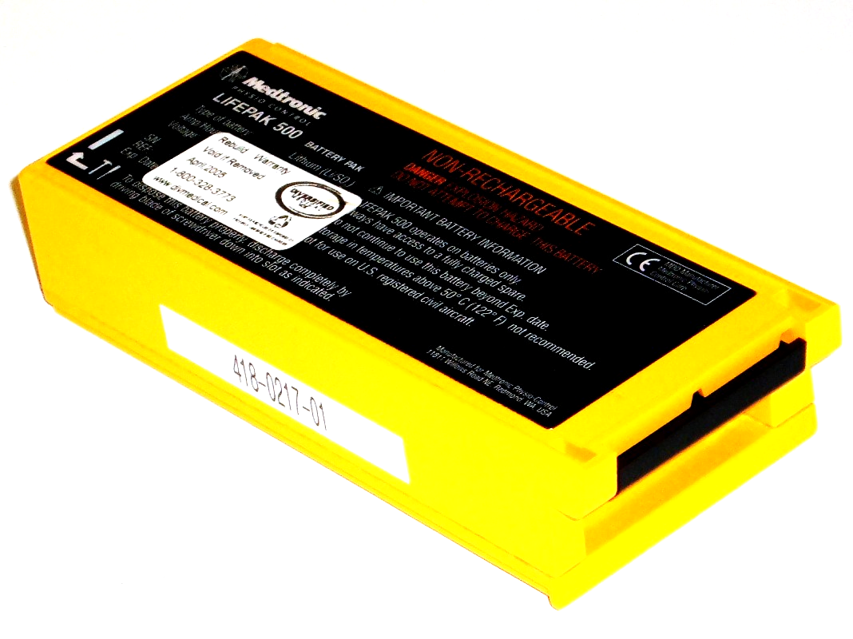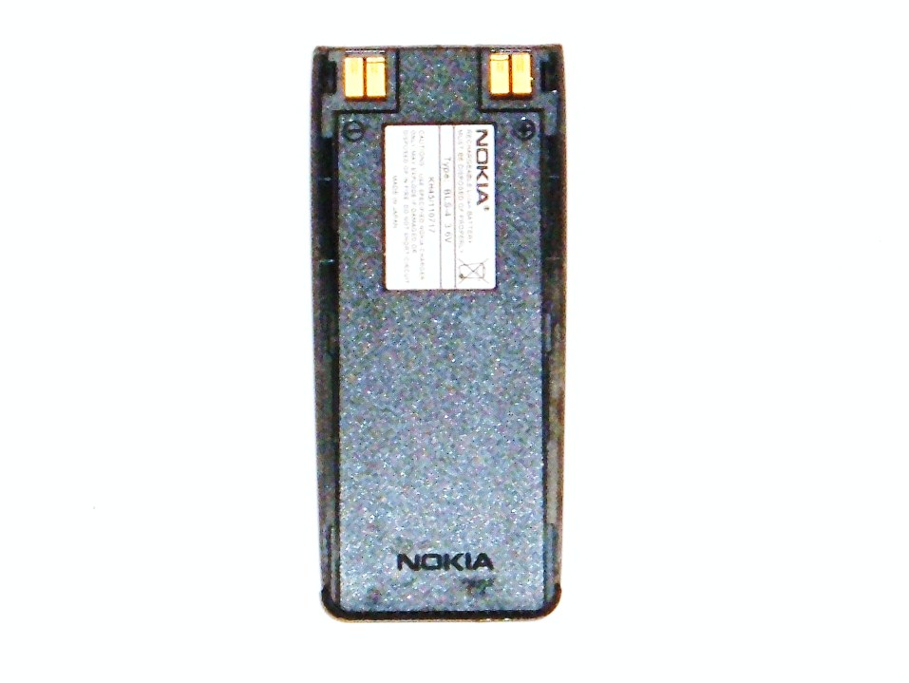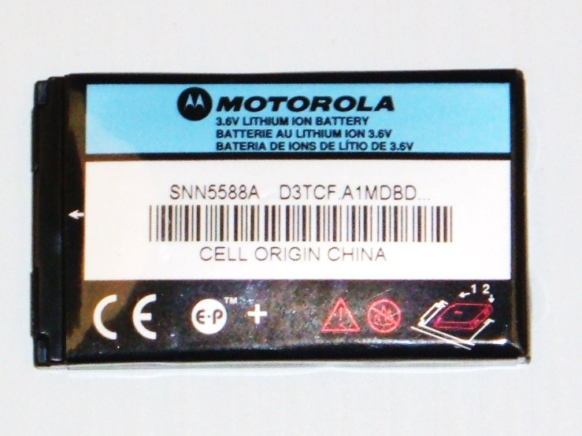

- Batteries must be packaged in a way to avoid short circuits and taped or separated so that electrically active terminals cannot come into contact with each other. Terminals (both terminal ends) may be taped, bagged, or placed in a non conductive material (Mineral Oil).

- The gross weight of the shippable container must be 66 lbs. Maximum

- The shippable container must meet D.O.T. Packaging Group II requirements

- The shipping container must be capable of passing a 1.2 meter drop-test in any direction without causing the spillage of the contents of the packaging, damaging the batteries, or shifting the contents which could lead to battery short circuiting.

- Lithium-Primary Batteries require a UNIVERSAL WASTE label.
D.O.T. Shipping Description: Lithium Metal Battery, Class 9, UN 3090, PG II
(Required on the Container)

- Lithium-Ion Batteries require a NON-REGULATED WASTE label.
D.O.T. Shipping Description: Lithium-Ion Battery, Class 9, UN 3480, PG II
(Required on the Container)

- The shippable container must be marked with a Class 9 Label. The label must be a background of contrasting color and must be at least 6 mm in height.

Lead-Acid Batteries (Vented and SSLA):

Common in cars, lead-acid batteries also power electric wheelchairs, computer UPS units, continuous back-up power supply systems, and other emergency power supply applications. These batteries contain a highly corrosive acid (sulfuric) and are capable of causing fires from short circuits.

To ship lead-acid batteries by surface (rail, truck, sea vessel, etc) within, to and from the United States, the shipments must meet the criteria shown below.

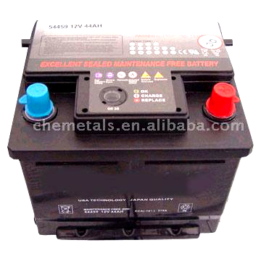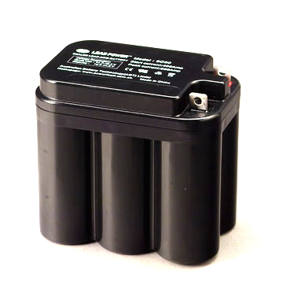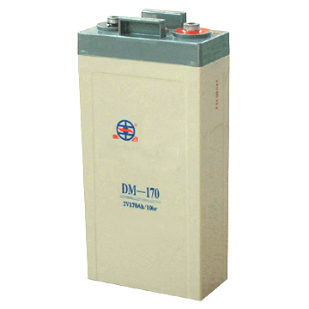

- Batteries must be arranged on a pallet in a manner to prevent short circuits. Battery terminals must be taped and separated by cardboard if stacked so that electrically active terminals cannot come into contact with each other.

- Tested, proven Non-Spillable batteries are allowed to be shipped as non-hazardous within the U.S. Batteries and packaging must be marked "NONSPILLABLE" or "NONSPILLABLE BATTERY.

- The shippable container must meet D.O.T. Packaging Group III requirements.

- D.O.T. Shipping Description: Battery, Wet, Non-Spillable, Class 8, UN 2800, PG III
(Required on the Container) (Lead-Acid Battery Dry Cells, SSLA)

- Lead Acid batteries require a UNIVERSAL WASTE label

- The shippable container must be marked with a Class 8 Label, Corrosive, as shown below.
The label must be a background of contrasting color and must be at least 6 mm in height.

Nickel-Cadmium, Sealed Cells and Power-Packs:

Generally are recognized as batteries used in portable power tools, laptop computers, emergency back-up power supplies, and other portable devices. The battery and power-pack must be packaged in a manner that prevents the generation of a dangerous quantity of heat and short-circuit.

Special regulations apply to shipping these batteries (49 CFR 178). To ship nickel-cadmium batteries and power-packs by surface (rail, truck, sea vessel, etc) within, to and from the United States, the shipments must meet the criteria shown below.

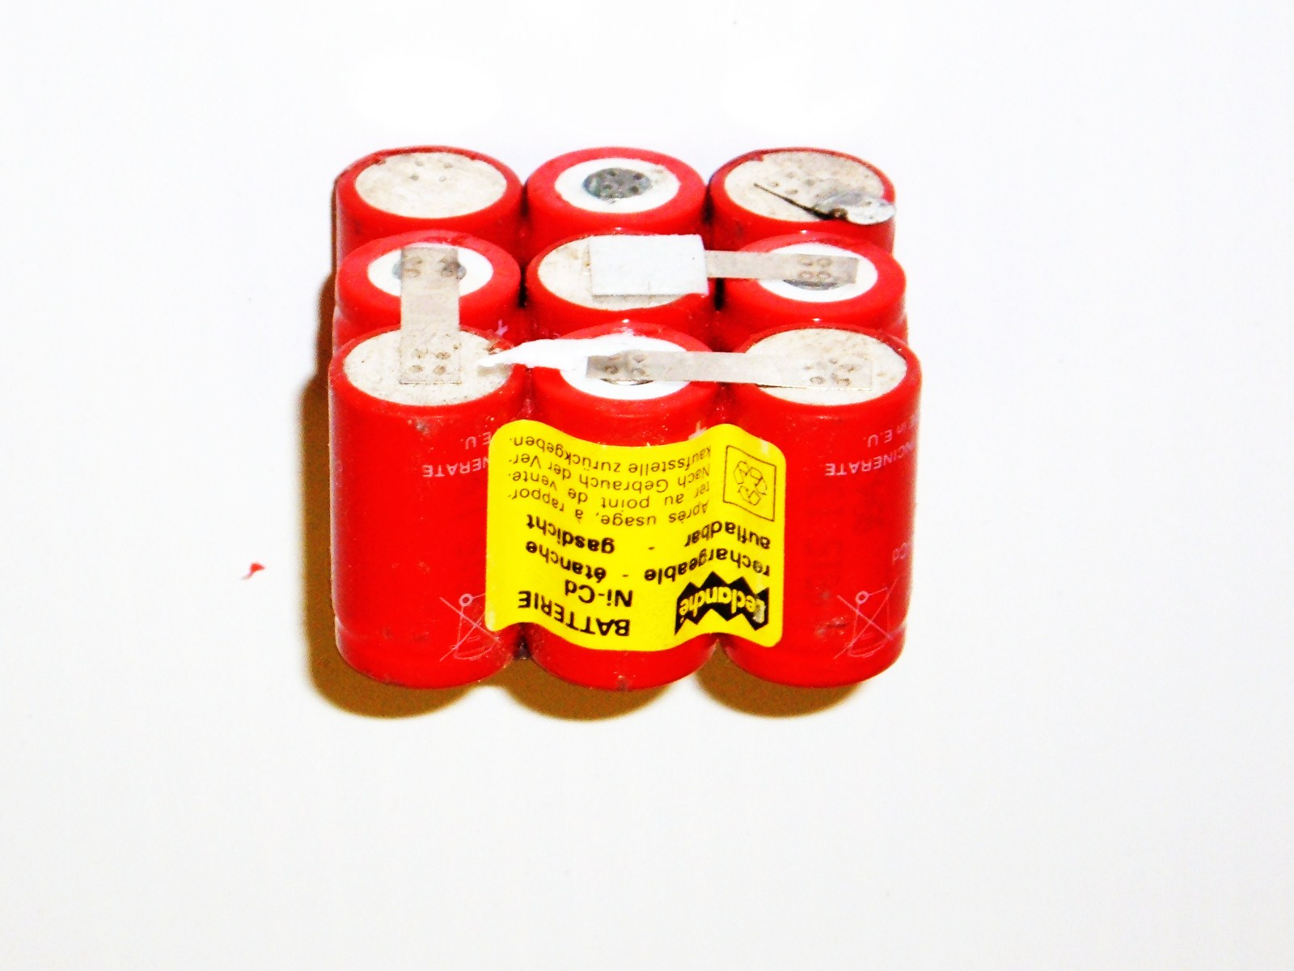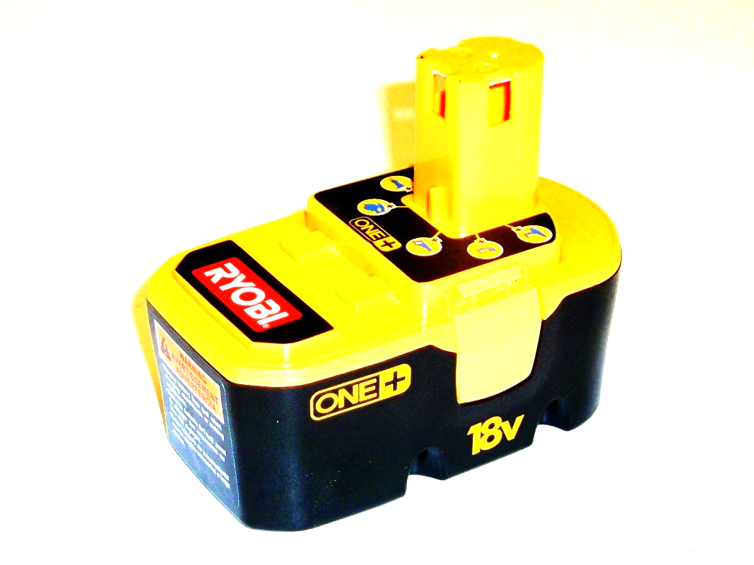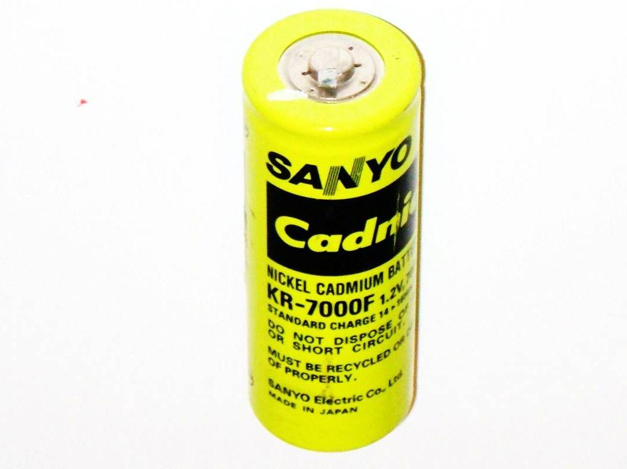

- Batteries must be packaged in a way to avoid short circuits and taped (both terminal ends) or separated so that electrically active terminals cannot come into contact with each other. Terminals may be taped (both terminal ends) or bagged.

- The shippable container must meet D.O.T. Packaging Group III requirements

- D.O.T. Shipping Description: Battery, Dry, Containing Potassium Hydroxide Solid
(Required on the Container) Class 8, UN 3028, PG III
(Alkaline and Nickel-Cadmium Batteries)

- All Nickel-Cadmium Batteries require a UNIVERSAL WASTE label.

- The DOT Approved Shipping Container (Packaging Group III Requirements) must be marked with a Class 8 Label, Corrosive. The label must be a background of contrasting color and must be at least 6 mm in height.

Nickel-Cadmium, Industrial Cells:

Commonly used in Emergency Back-up Power Supplies, Commercial Rail Systems (Class I, II, II, Short-lines and Metro Rail Systems) and military applications. Batteries must be packaged in a manner that prevents the generation of a dangerous quantity of heat and short-circuits.

Special regulations apply to shipping these batteries (49 CFR 178). To ship nickel-cadmium batteries and power-packs by surface (rail, truck, sea vessel, etc) within, to and from the United States, the shipments must meet the criteria shown below.

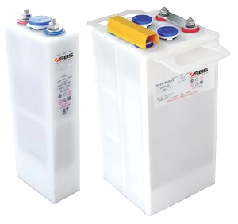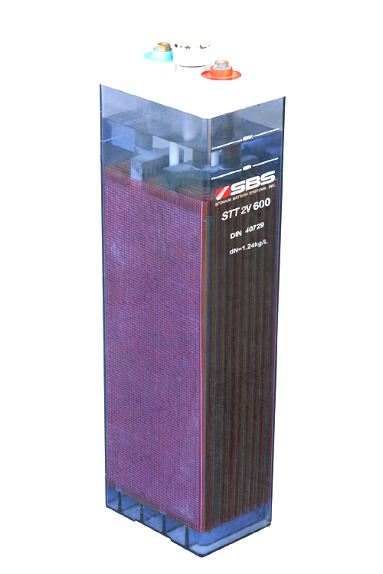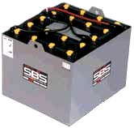

- The shippable container must meet D.O.T. Packaging Group III requirements

- D.O.T. Shipping Description: Battery, Wet, Containing Potassium Hydroxide Liquid
(Required on the Container) Class 8, UN 2795, PG III (Nickel-Cadmium Batteries)

- All Nickel-Cadmium Batteries require a UNIVERSAL WASTE label.

- The shippable container must be marked with a class 8 label (As seen above). The label must be a background of contrasting color and must be at least 6 mm in height.

Alkaline (Household Batteries):

The common alkaline battery (e.g., Household Battery) is not regulated as hazardous materials. When shipped, if separated from other battery types, then the insulation of the battery’s terminals is not required.

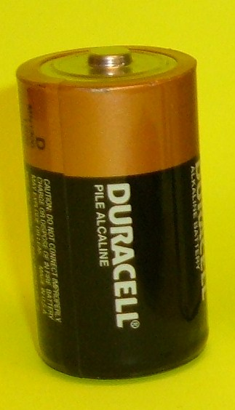

D.O.T. Shipping Description: No labeling or packaging required. (When shipped with other battery types, then the shipping and packaging requirements of the most stringent battery type will apply)

- Alkaline Batteries require a NON-REGULATED WASTE label.

Nickel-Metal Hydride:

Found in Electric Vehicles (commercial design and application), Laptop Computers, and Portable-Power Tools, Cellular Phones and other electronic devices. As a common sealed-cell or power-pack battery, it is not regulated as hazardous materials; however, the DOT packaging requirements must be met because all batteries can cause fires from short circuits if the battery terminals are not protected.

- Batteries must be packaged in a way to avoid short circuits and taped (both terminals) or separated so that electrically active terminals cannot come into contact with each other. Terminals may be taped (both terminal ends) or bagged.

- D.O.T. Shipping Description: Battery, Dry, Non-Spillable , UN 2800, PG III

- Nickel-Metal Hydride batteries require a NON-REGULATED Waste label.

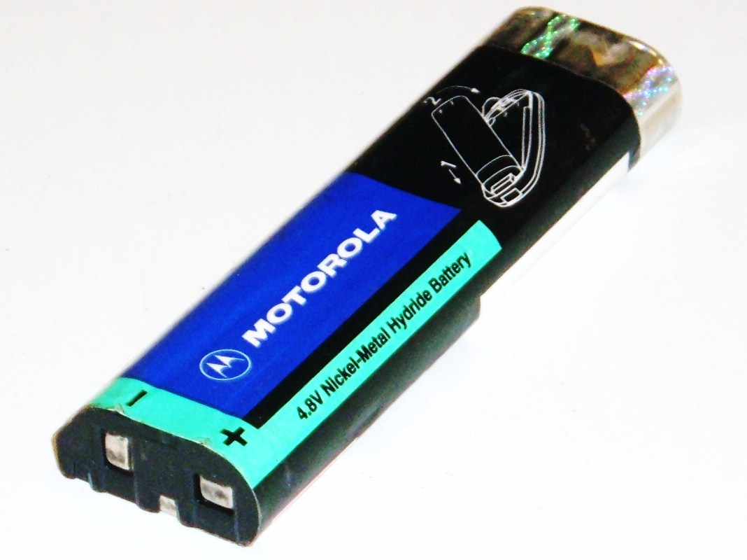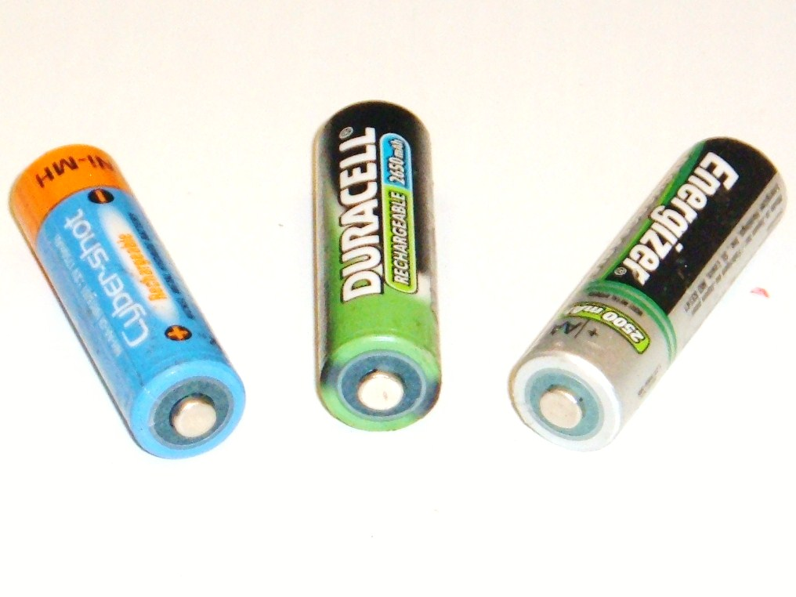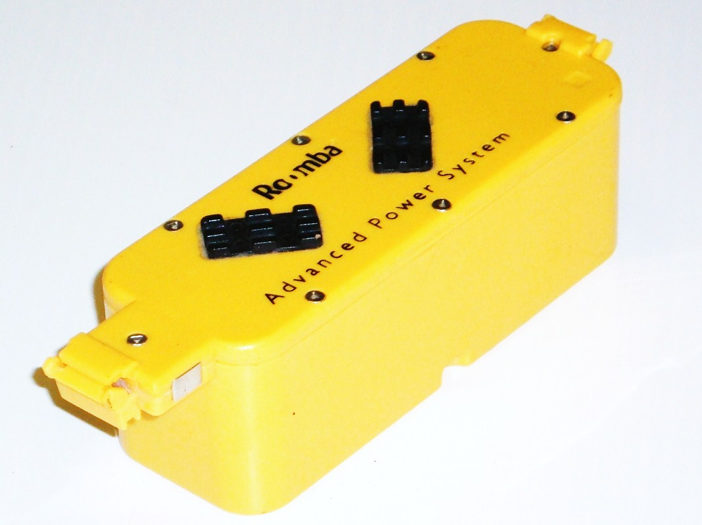

Devices with Batteries:

Any device with batteries must not turn on (operate) while in transit. Before shipping, remove the batteries and protect the terminals. Even very simple devices like flashlights or portable-power tools can generate a dangerous quantity of heat if accidentally activated.

Shipping Services:

Always use ground services to ship batteries. Never use air services to ship batteries accumulated for recycling for safety reasons, as such shipments are prohibited by regulation (see e.g., IATA Dangerous Goods Regulations, Special Provision A154).

Shipments requiring Hazardous-Materials Handling are to be contracted by Haz-Mat shippers only.

If you have additional questions concerning packaging, placarding, shipping bill requirements, proper DOT descriptions, please contact Metal Conversion Technology at 678-721-0022.

